**BSc. (Hons.) COMPUTER SCIENCE**

**GE III MATHS PRACTICAL**

**Shubhang Gupta**

**19/78098**

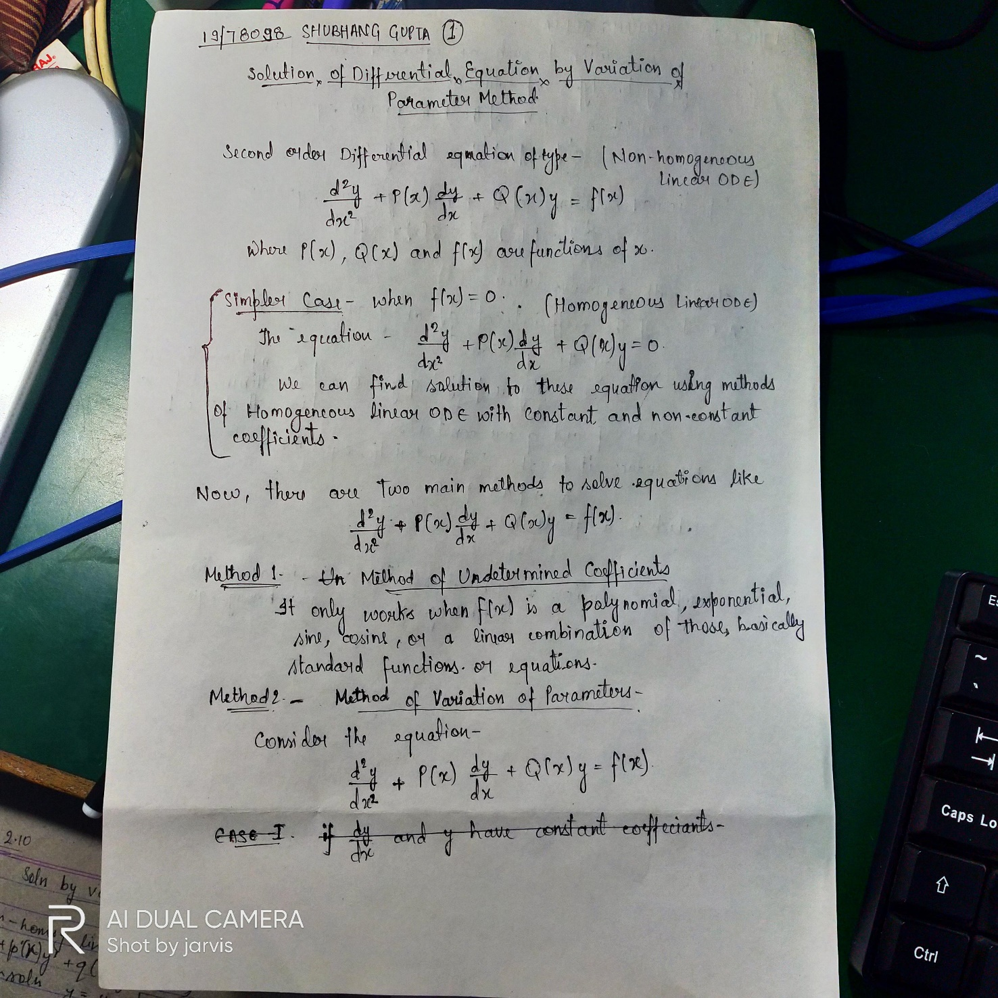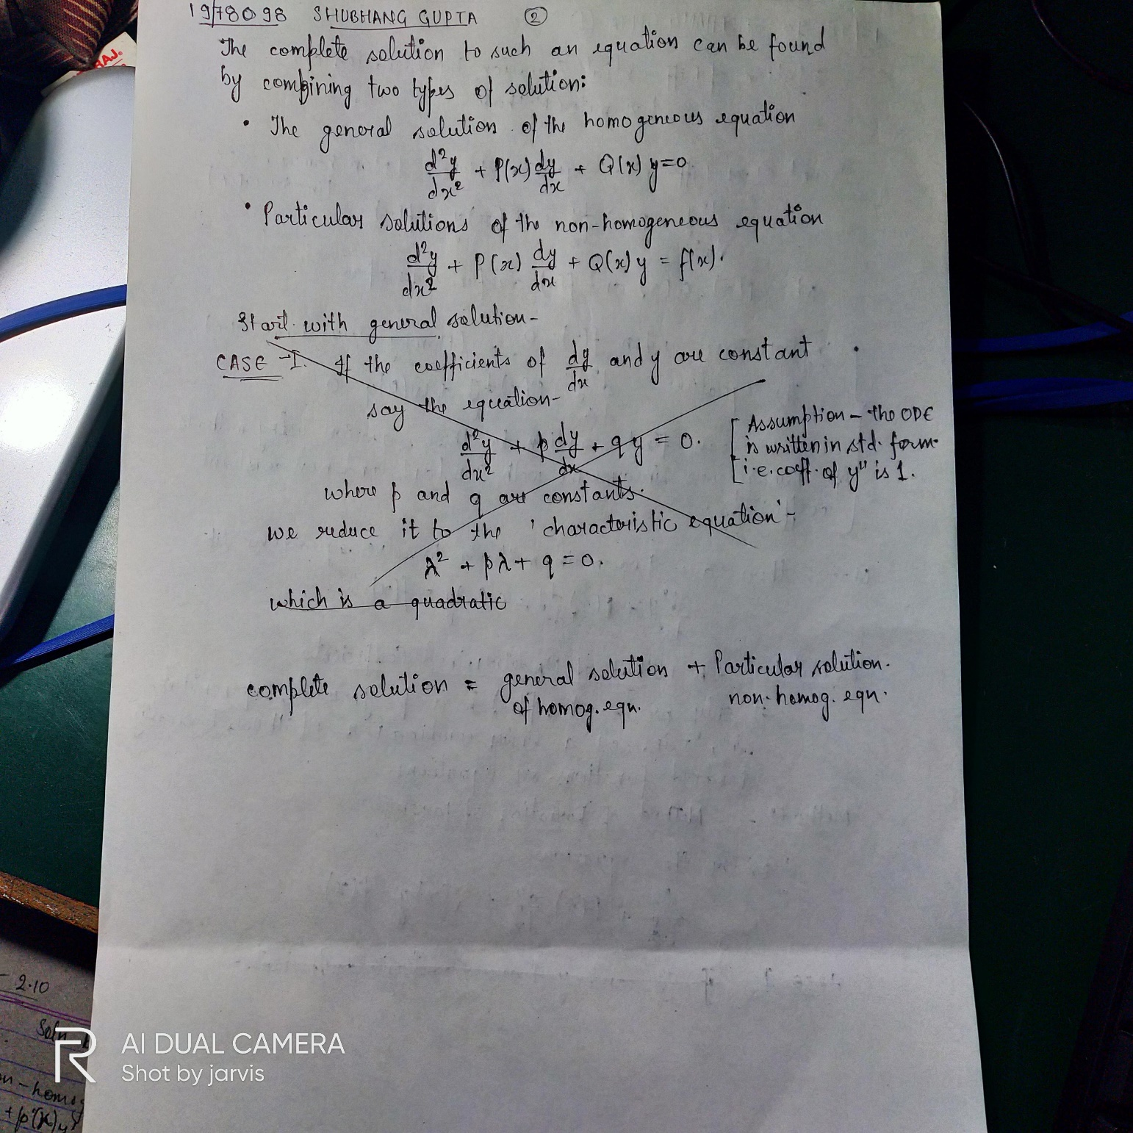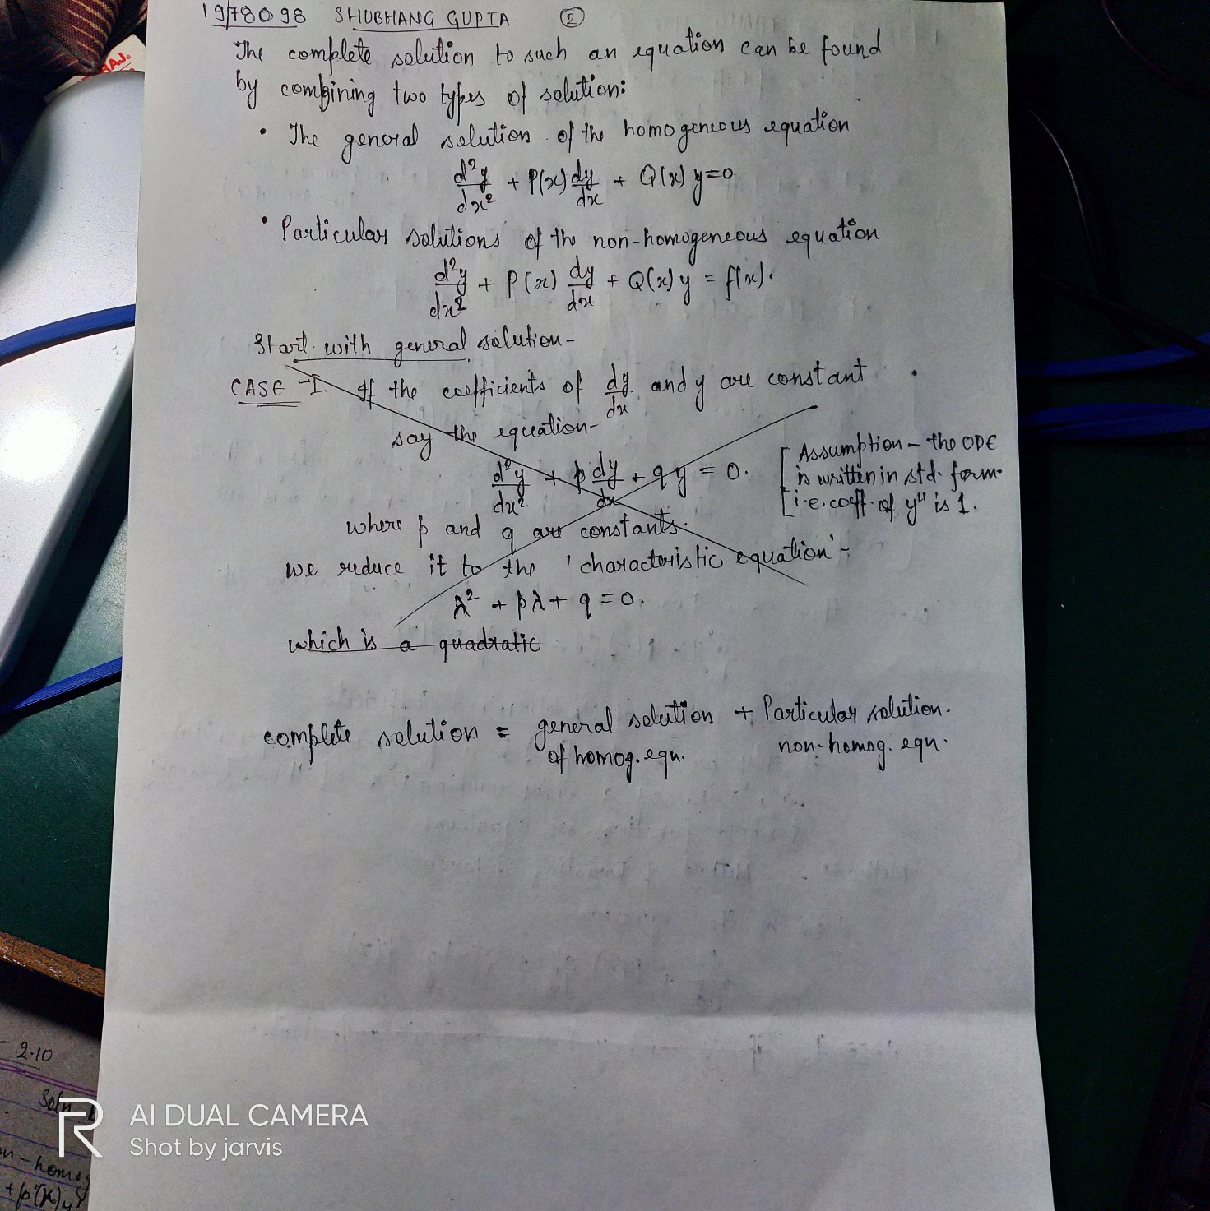 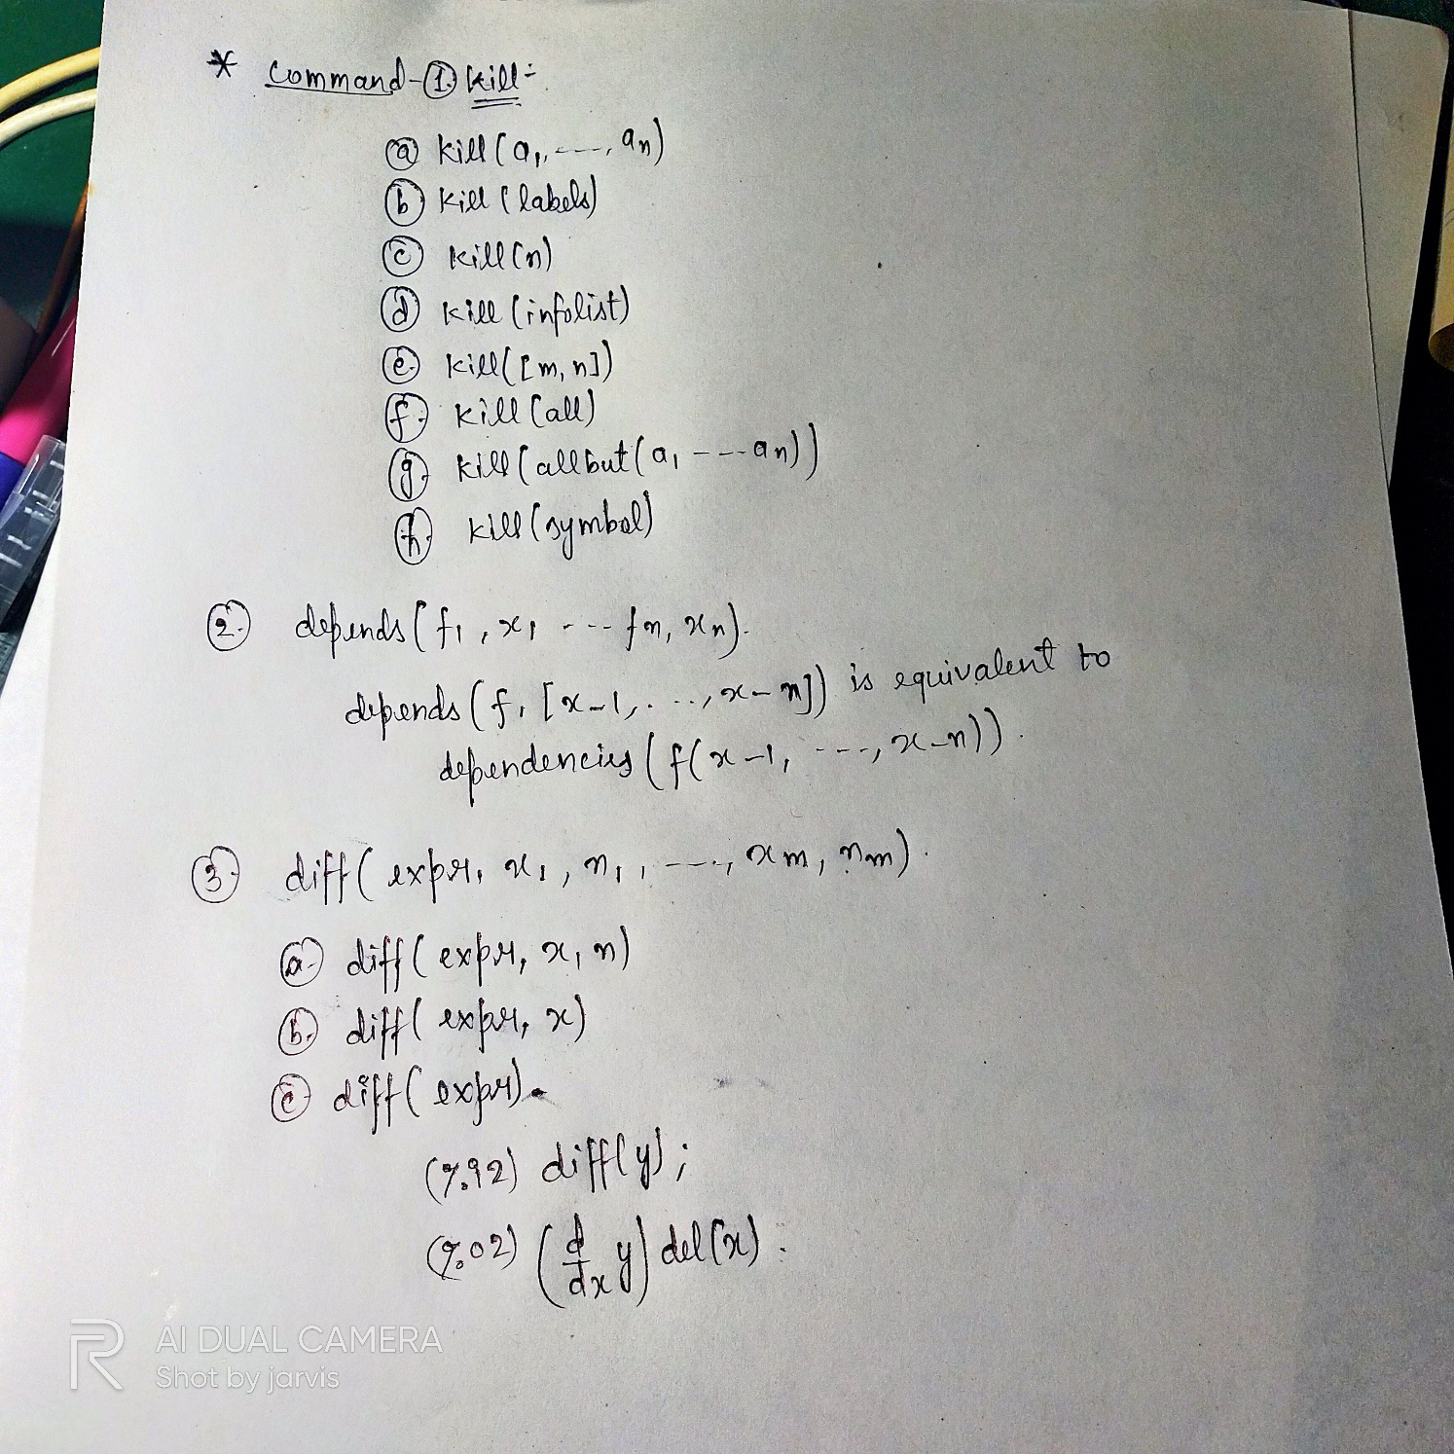

**PYUSH DEEP**

**19/78096**

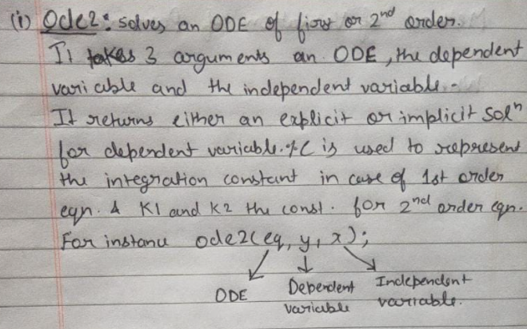 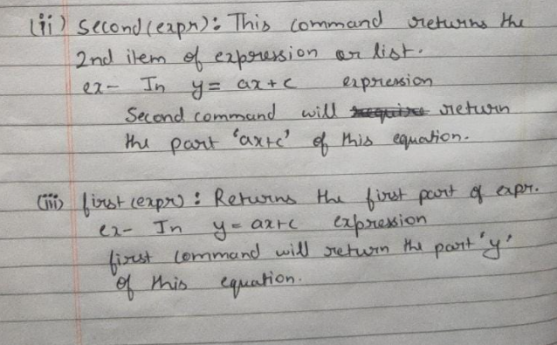

**Kunal Kumar Giri**

**19/78090**

matrix--> Returns a rectangular matrix which has the rows row_1, …, row_n. Each row is a list of expressions. All rows must be the same length.

determinant--> Computes the determinant of M by a method similar to Gaussian elimination.

m: matrix ([a,b] , [diff(a,x), diff(b,x)]);

w: determinant(m); 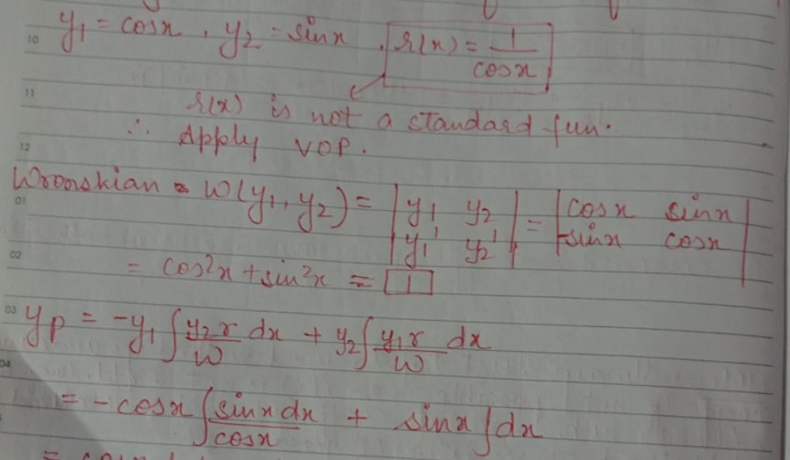

**Harsh Yadav**

**19/78092**

